**Project Design Phase-II**

**Data Flow Diagram & User Stories**

|  |  |
| --- | --- |
| Date | 26 june 2025 |
| Team ID | LTVIP2025TMID37102 |
| Project Name | “Smart sdlc-Ai-Enhanced software development life cycle |
| Maximum Marks | 4 Marks |

**Data Flow Diagrams:**

A Data Flow Diagram (DFD) is a traditional visual representation of the information flows within a system. A neat and clear DFD can depict the right amount of the system requirement graphically. It shows how data enters and leaves the system, what changes the information, and where data is stored.



Example: DFD Level 0 (Industry Standard)

**Example:** [**(Simplified)**](https://developer.ibm.com/patterns/visualize-unstructured-text/)

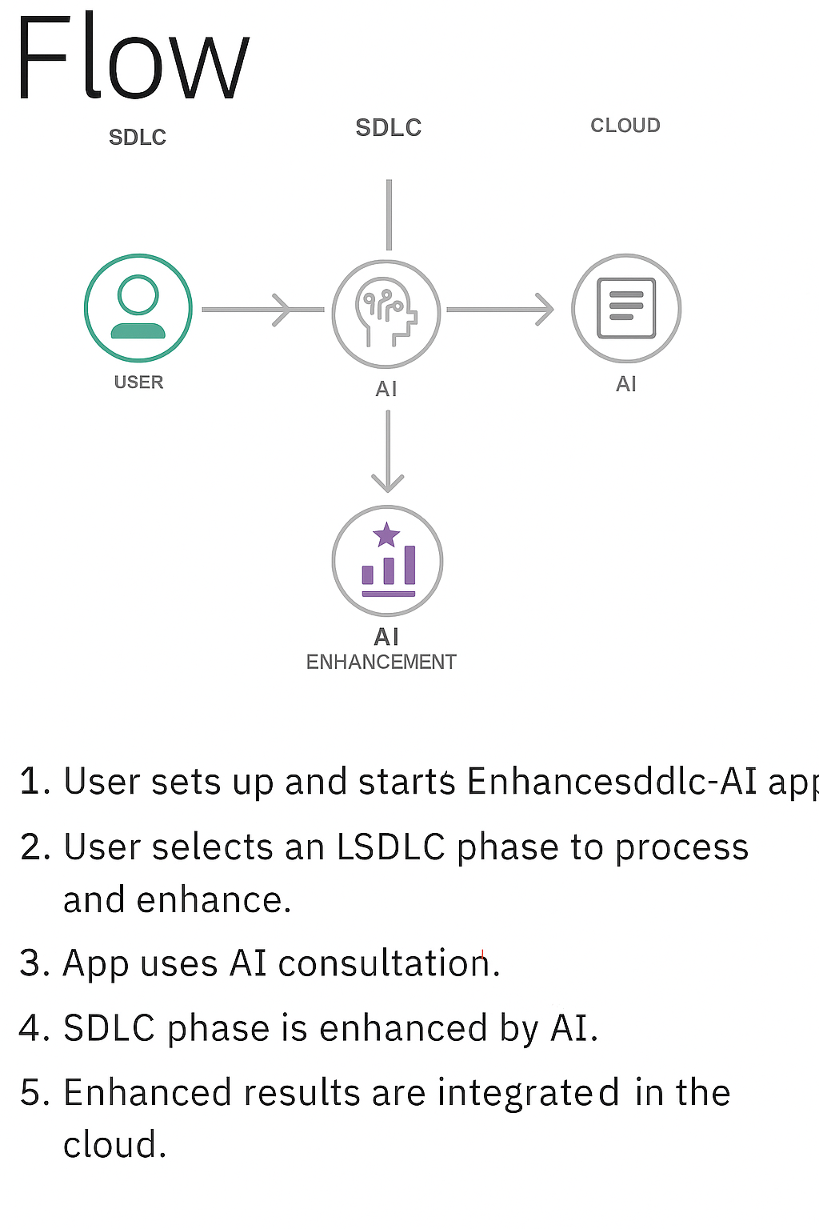

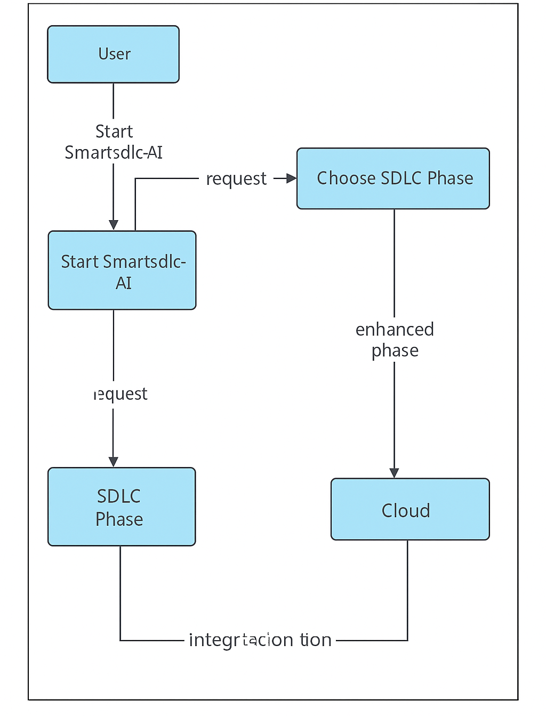

**User Stories** Use the below template to list all the user stories for the product.

|  |  |  |  |  |  |  |
| --- | --- | --- | --- | --- | --- | --- |
| User Type | Functional Requirement (Epic) | User Story Number | User Story / Task | Acceptance Criteria | Priority | Release |
| Customer (Web user) | Requirement Upload | USN-1 | As a user, I can upload requirement documents in PDF or DOCX format. | The document is uploaded and listed for analysis. | High | Sprint-1 |
| Customer (Web user) | Requirement Upload | USN-2 | As a user, I can type custom requirements manually in a text box. | The input is saved and used for code generation. | Medium | Sprint-1 |
| Customer (Web user) | Requirement Analysis | USN-3 | As a user, I can view categorized and structured requirements extracted from uploaded files. | Requirements are classified and shown correctly. | High | Sprint-1 |
| Customer (Web user) | Code Generation | USN-4 | As a user, I can generate backend code by selecting a requirement and language. | Code is generated and displayed/downloadable. | High | Sprint-2 |
| Customer (Web user) | Test Case Generation | USN-5 | As a user, I can generate unit test cases for submitted code. | Test cases are displayed in standard format. | High | Sprint-3 |
| Customer (Web user) | Bug Fixing | USN-6 | As a user, I can submit buggy code and get AI-suggested fixes. | Errors are highlighted and suggestions shown. | Medium | Sprint-3 |
| Customer (Web user) | Code Summarization | USN-7 | As a user, I can generate documentation or summary of a code snippet. | Summary is generated and can be downloaded. | Medium | Sprint-4 |
| Customer (Web user) | Chatbot Assistant | USN-8 | As a user, I can ask development-related questions to an AI chatbot. | AI chatbot provides relevant answers or links. | Medium | Sprint-4 |
| Administrator | User Management | USN-9 | As an admin, I can view registered users and their activity logs. | User details and actions are visible in admin panel. | Medium | Sprint-4 |
| Administrator | Analytics & Monitoring | USN-10 | As an admin, I can monitor which modules are most used and track system performance. | Usage stats and API logs are available. | Medium | Sprint-4 |